Set Theory

1. Basic Set Relations

A set is an unordered collection of distinct objects,

called elements or members of the set.

A set is said to contain its elements.

We write a ∈ A to denote that a is an element of the set A.

The notation a ∉ A denotes that a is not an element of the set A.

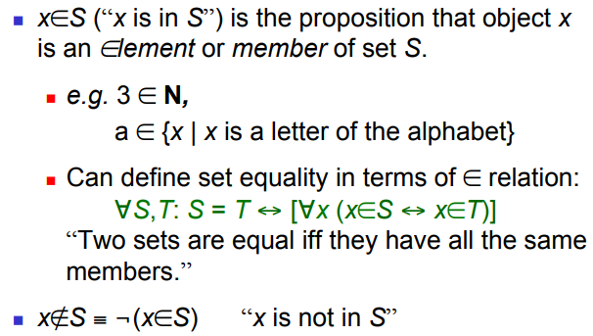

1. The Empty Set

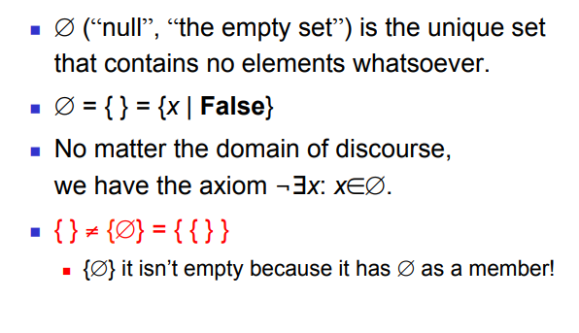

1. Subset and Superset

The set A is a subset of B, and B is a superset of A, if and only if every element of A is also an element of B.

We use the notation A ⊆ B to indicate that A is a subset of the set B.

If, instead, we want to stress that B is a superset of A, we use the equivalent notation B ⊇ A.

(So, A ⊆ B and B ⊇ A are equivalent statements.)

*Showing that A is a Subset of B To show that A ⊆ B,

show that if x belongs to A then x also belongs to B.

*Showing that A is Not a Subset of B To show that A ⊈ B, find a single x ∈ A such that x ∉ B.

For every set S, (i ) ∅ ⊆ S and (ii ) S ⊆ S.

BUT,

Two sets are equal if and only if they have the same elements.

Therefore, if A and B are sets, then A and B are equal if and only if

∀x(x ∈ A ↔ x ∈ B).

We write A = B if A and B are equal sets.

1. Proper (Strict) Subsets & Supersets

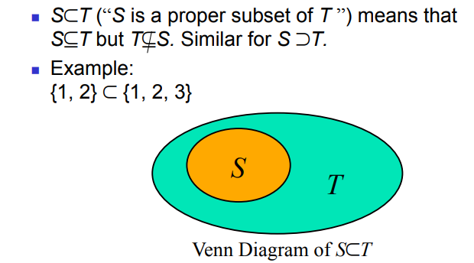

1. Cardinality and Finiteness

If there are exactly n distinct elements in S where n is a non-negative integer,

We say that S is a finite set and that n is the cardinality of S.

The cardinality of S is denoted by |S|.

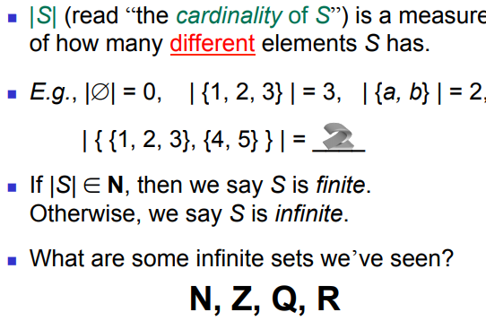

1. The Power Set Operation

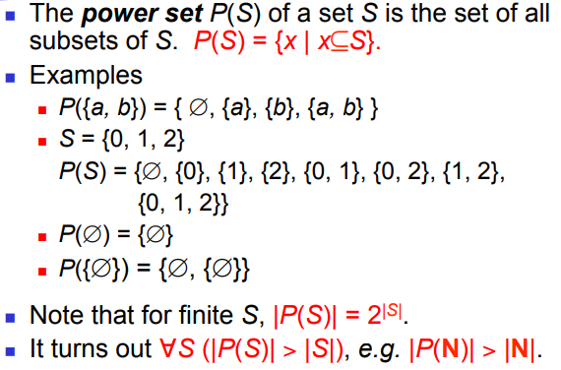

1. Ordered n - Tuples

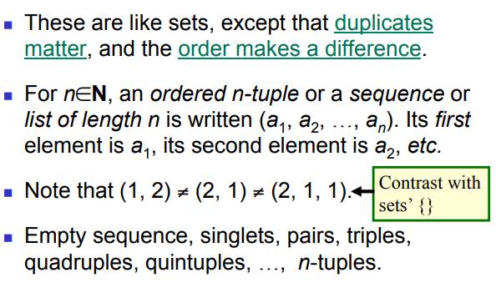

1. Cartesian Product of Sets.

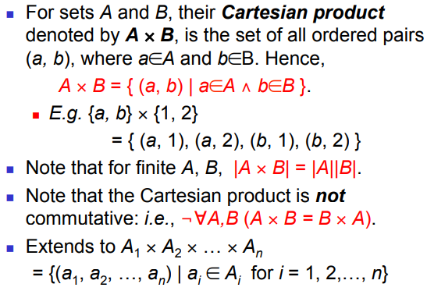

1. The Union Operator

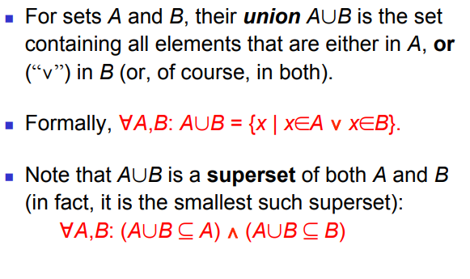

1. The Intersection Operator

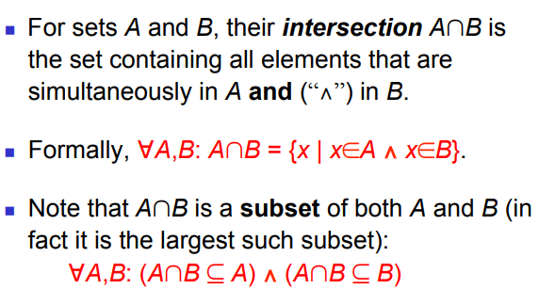

1. Disjointedness

Two sets A, B are called disjoint (i.e., unjoined)

iff their intersection is empty. (A ∩ B = ∅) !

Example: the set of even integers is disjoint with the set of odd integers.

1. Inclusion-Exclusion Principle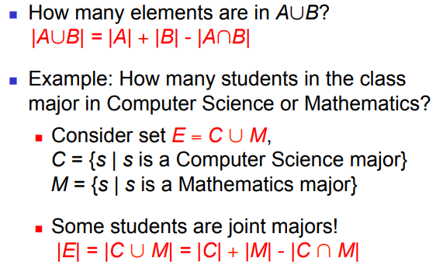
2. Set Difference  
   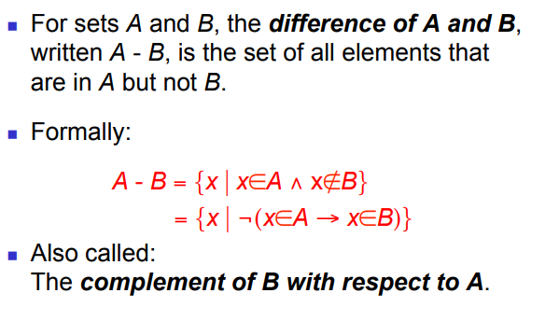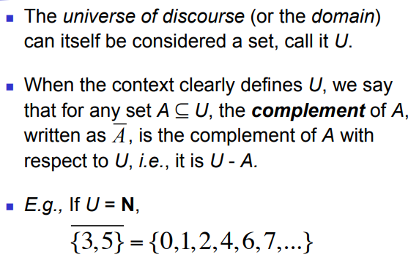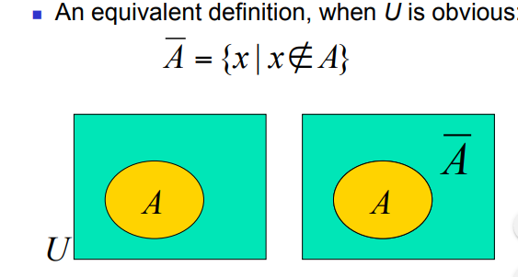
3. Interval Notation

